B.R.INTERNATIONAL PUBLIC SCHOOL,KURUKSHETRA
HOLIDAYS HOMEWORK
CLASS VIII
NOTE: Revise complete syllabus of periodic –I of all the subjects.
English
1. Write 2 Stories.
Clues:-
(i) Enjoyed going for long walks- visit to Dehradun - huge forest taking shortcut through the wors, a tree topples me understand.
(ii) Hari drove fast. He was already late for office- got up late and it was first day of job.
2. Letter Writing: - Letter to the Editor (2)
1) Write a letter to the Editor making a plea to the common people to switch over to solar energy to conserve electricity.
2) Write a letter to the Editor for making aware to the people about the bad conditions of roads of your area and increasing number of accidents.
3. Article Writing:- (2)
1) All work is dignified- no work is menial.
2) Owing things is human, sharing them is divine.
4. Revise Chapters (Book- Honey Dew)
L-1, 2, 3, 4
Revise Chapters (Book- It so happened)
L-1, 2, 3
5. Read Newspaper daily.
6. Do Comprehension Passages daily (From Mastering Grammar)
7. Write 20-20 Sentences of all tenses.
8. Read Novel- Frame at least 5 Questions.
Eg-1. Write about Author- Shakespeare.
Paste- Photograph of Shakespeare.
His. D.O.B
His Awards
His Creations
Do it on A4 Size Sheet.
- Write About Characters of the novel
- Type of Novel.
- Summary in about 100 words.

9. Help your parents and grandparents in vacation
Then write
- How did you help them.
-Do some creative work and write about that.
Science
1. Revise Lesson -1 ,2,3,4
2. Write any five internal questions from L-1,2,3,4
3. Project work:
1. visit a farm, nursery or a garden nearby, gather information aboutl
(i) Importance ofseed-selection.
(ii) Method of irrigation.
(iii) Manure/ Fertilisers used.
(iv) Effect of continous rain on plants.
2. Visit a doctor. Find out why antibiotics should not be overused. Prepare a short report.
Social Science
1. On the outline map. Label the following.
(i) 29 states of India.
(ii) Minerals found in India.
(iii) Tribal’s found in India.
2. Give your experience about domestic violence. What you think to do to stop domestic violence.
3. Write short essay on Secularism and Communal Harmony
4. Give an experience of an incident in your life in which your dignity was violated. How did this make you feel. (100 words).

(Computer)
1. Learn Ch-1, 2,3 (Internal +Exercise)
2. Draw the following diagrams on A4 size sheet:
(i) Networking
(ii) Types of Network.
(iii) Network Security.
(iv) Types of topology.
3. Draw the following diagrams on A4 size sheet:
(i) Infrared
(ii) Bluetooth
(iii) Wi-Max
(iv) Wi-Fi
4. Draw the tools of Photoshop & Write their names in notebook.
(ART & CRAFT)
Holiday’s homework
1. Insect study (pg no. 24-25)
2. Animal Study (pg no. 26, 27, 28, 30)
3. Tulip Flower (pg no. 92)
4. Paper frog (pg no. 91)
Revise syllabus and do practice

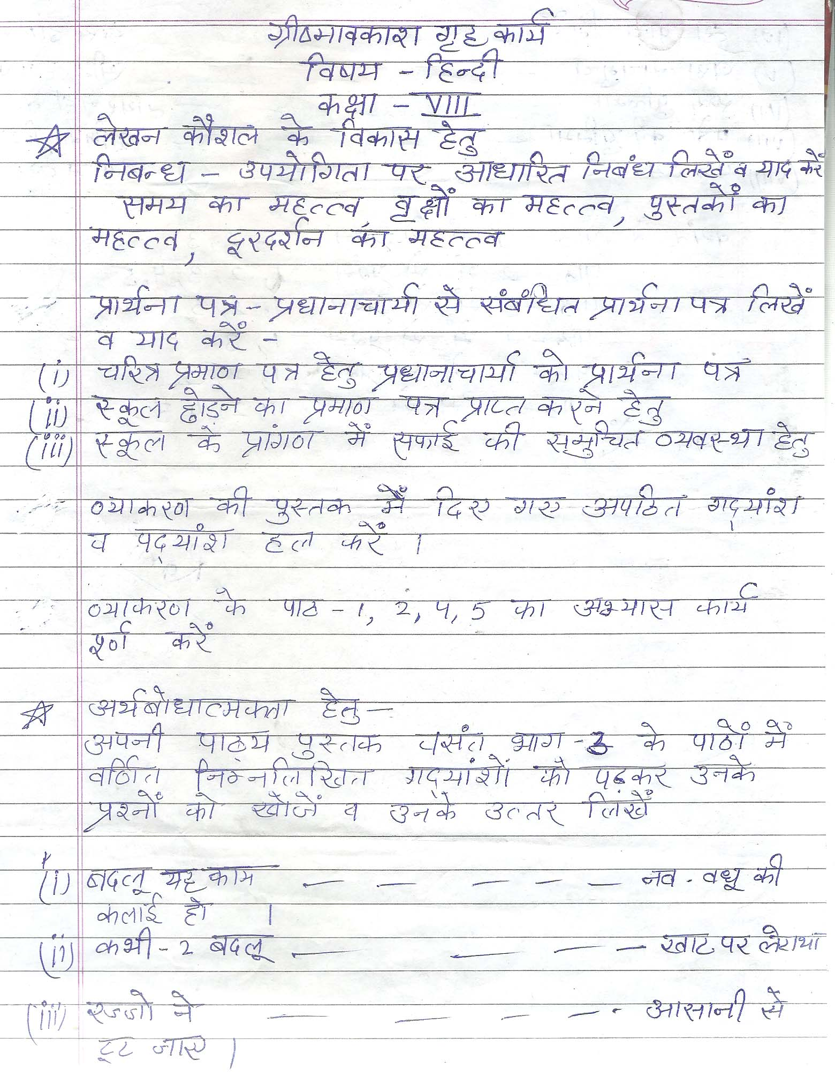

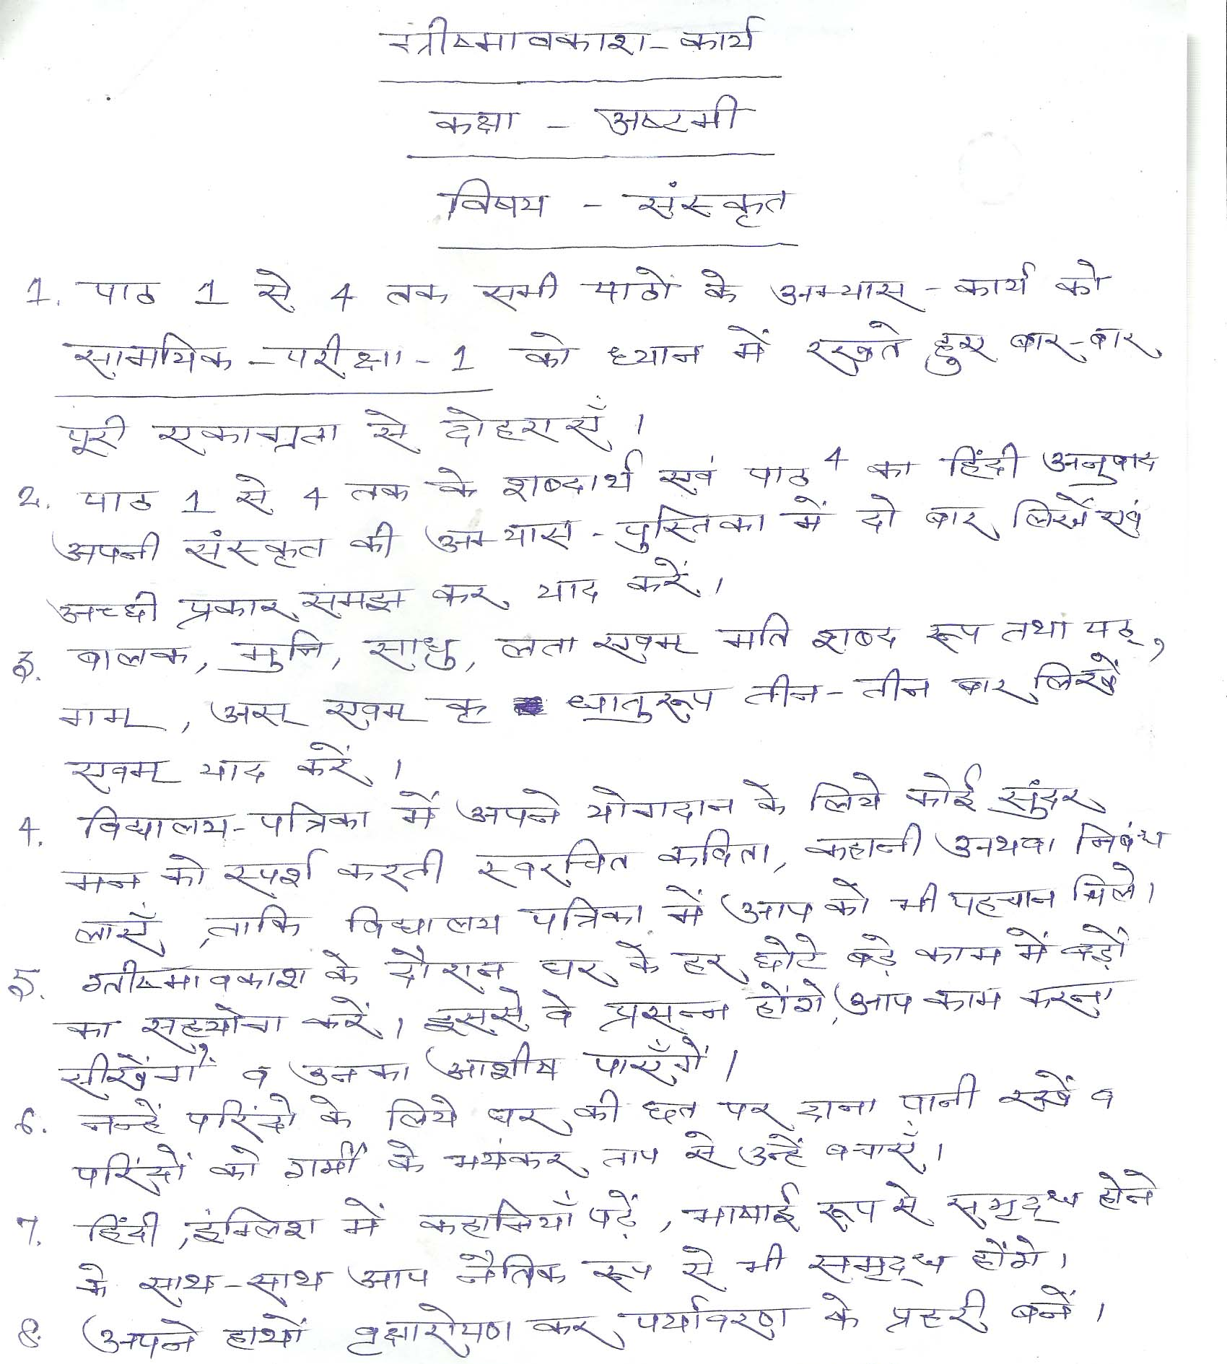

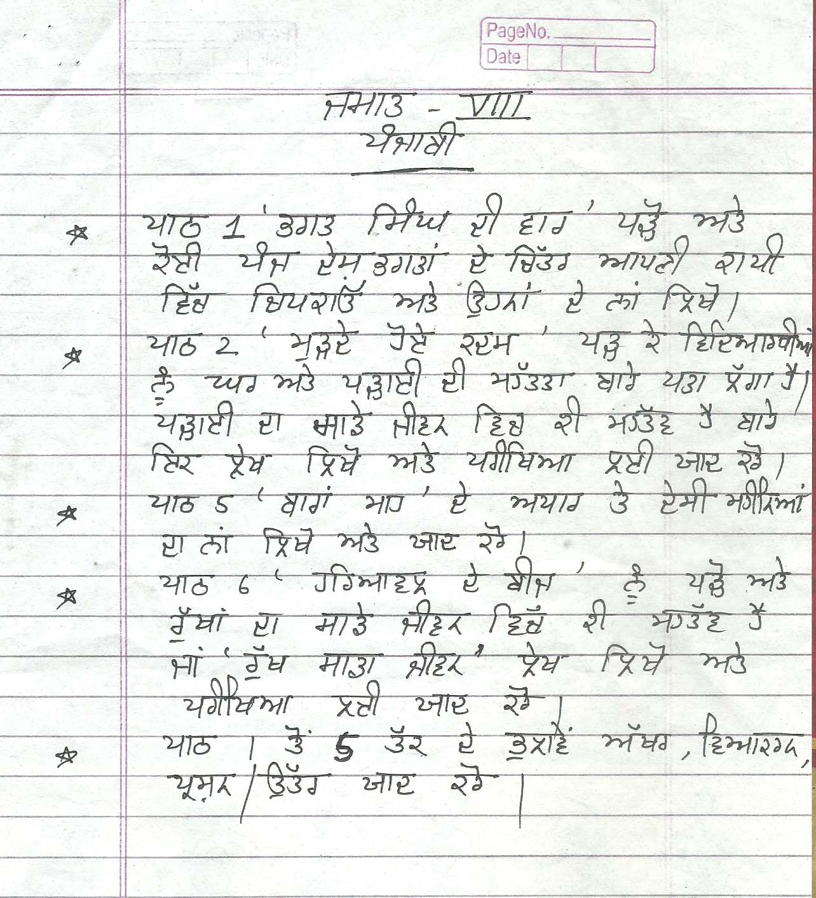

(Maths)
1. Write & Learn dodging tables (2 to 20) daily.
2. Arrange the following rational numbers in ascending and descending order:
a) $\frac{8}{15}, \frac{-3}{10},\frac{-13}{20},\frac{17}{-30}$ b) $\frac{-13}{5},-2,\frac{7}{-3},\frac{2}{3}$
3. Define rational numbers.
4. The sum of two numbers is $\frac{-23}{9}$. If one of the number is $\frac{5}{9}$. What is the other number.
5. What number should be subtracted from $\frac{3}{5}$ to get $\frac{5}{3}$?
6. Simplify (i) $\frac{18}{14}×\frac{5}{4}×\left(\frac{-49}{15}\right)+\frac{8}{5}×\frac{15}{7}$
(ii) $\frac{-3}{5}÷\left(\frac{-12}{35}÷\frac{1}{28}\right)$
7. The product of two numbers is $\frac{28}{121}$. If one of the number is $\frac{2}{3}$, find the other number.
8. The area of a rectangular field is $75\frac{3}{4}sq.m$ . If its breadth is $12\frac{5}{8}m$. Find its length.
9. Find five rational numbers between $\frac{-5}{6}and \frac{3}{8}$.
10. Find whether the 14641 and 7688 are perfect.
11. Find the smallest number by which 1620 should be divided to get a perfect square. Find the square root of the square number to obtained.
12. Find the smallest number by which 396 must be multiplies so that the product becomes a perfect square.
13. Find square root of 16384, 71289 by division method.
14. Find the smallest six-digit number which is a perfect square.
15. Find the greatest four digit number which is perfect square.
16. Find the square of 0.053361, 0.9801.
17. Find the smallest number by which 392 should be multiplied to make a perfect cube.
18. Find the smallest number by which 576 must be divided to get a perfect cube.
19. Evaluate: $3\sqrt{\frac{1331}{9261}}$ (ii) $\sqrt[3]{-216}×\sqrt[3]{-15625}$
20. Solve (i) 7x-5=16
(ii) 3m+4=8m+24
(iii) $\frac{6x+1}{2}=\frac{7x-3}{3}-1$
(iv) $\frac{2+3y}{1+5y}=\frac{4}{3}$
21.A number is such that it as much greater that 17 as it is less than 63. Find the number.
22. A number consists of two digits whose sum is 6. If 18 is added to the number, its digits are revered. Find the number.
23. Five years ago, a man was 7 times as old as his son. Five years , he will be 3 times as his son. Find their present age.
24. Verify $\frac{-4}{3}×\left(\frac{6}{5}×\frac{8}{9}\right)=\left(\frac{4}{-3}×\frac{6}{-5}\right)×\frac{8}{9}$
25. Divide the sum of $\frac{2}{7}and \frac{3}{5}$by their product.
Activity 1: Draw a pie chart of time spent by you during a day. Note down the time.
Activities School Homework Playing Sleeping other
Time (in hrs)

Activity 2 : Draw a pie chart for a particular day, you go to a market buy different items from a baker shop.
Item bread cake Pastries Biscuits Fruit bread
Sale in Rs.

