B.R. INTERNATIONAL PUBLIC SCHOOL, KKR
HOMEWORK for Class - V

Note: Revise the syllabus of Periodic-I of all subjects.
ENGLISH:
Do the Review-1 (Pg 26) in your grammar book.
- Do the comprehensions given on Pg 119,120,121,122,123,124,125,126,127,128
- Do pg 15 & 16 given in your English Conversation Practice book.
- Do calligraphy course at your own.
MATHEMATICS
- Write dodging table (2 to 20) daily.
- Revise and do review exercise of 4,5,11 (In maths note book)
- Do the worksheet given to you.
Activity-1 Plan your birthday party. Make a list of items you need for the party (Pg 118)
Activity -2 Write Indian and international number system by writing your parent’s cell phones numbers.
Arrange these numbers in ascending and descending order.
Write successor and predecessor of these numbers
Activity -3 Roll a dice up to 20 times and note down the numbers that comes in the tally marks table, prepare a bar graph that separates the outcome of the trial.
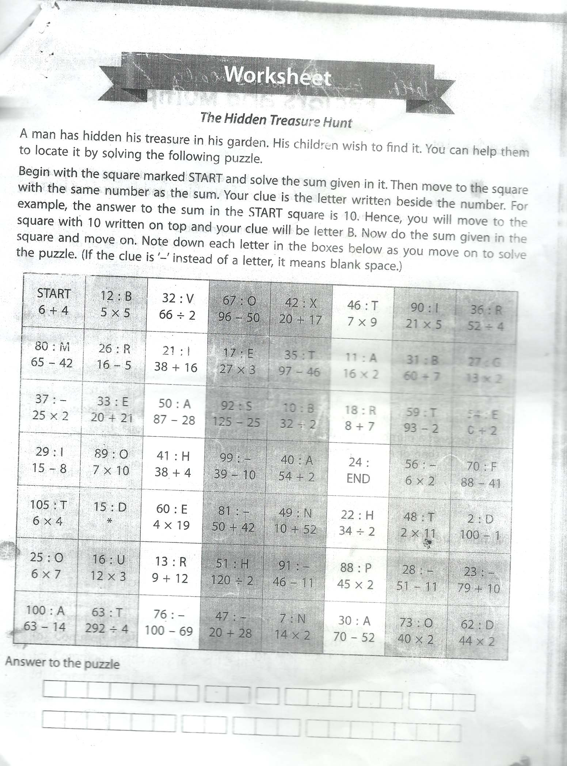
SCIENCE
- Collect and paste these in your science notebook.
  - Seven different types of seeds putting in small plastic bags.
  - Pictures of animals and birds which live on land, in air and in water.
- Prepare a First-Aid Box having
  - Cotton, A small scissor, Bandage, Band-Aid, Savlon/Dettol, Pudinhara etc.

SOCIAL SCIENCE
- Map work
  - States of India
  - India’s neighbouring countries.
- Make ‘This is my India’ collage using pictures, poems, phrases words or quotations.
- Select a ‘Historical Monument’ of India or the world. Draw or paste the picture of that place. Write down a paragraph on it.
- Collect the pictures of five freedom fighters of India and write five lines on each.
- Collect different types of soil in pouches and paste it in scrap book and write few lines about them
- Do all this work in scrap book.
- Good work will be appreciated.
COMPUTER
- Paste the colorful pictures of different type of operating system and Hardware of computer in notebook
- Learn L-1 and 2(complete) for Periodic 1 Exam
Art & Craft
Complete
- Body Parts (pg 10)
- Scenery (pg 11)
- Park (pg 15)
- Janamasthami (pg 19)
French language:
- 1. Learn and write 2 times in French note book ,Greetings ,accent sounds,
Le vocabulary Chapter -0.
- 2. Draw the French Flag in your note book.

