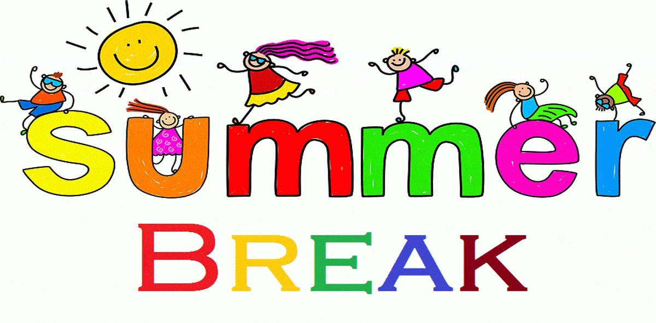
B.R INTERNATIONAL PUBLIC SCHOOL, KURUKSHETRA
CLASS-iii
Holidays Homework(2018-2019)
Note: Revise the syllabus of Periodic-1 of all subjects.
English:-
Eng. Reader- Lesson-1,2,3
Grammar - Lesson – 1
Application for –Sick Leave and Remission of fine.
Paragraph-Importance of Trees.
Practice writing –
- Read lesson-4 in reader book and try to do book work.
- Circle the difficult words and learn them from the notebook.
- Write a paragraph on ‘How would you like to spend your holidays?”
- Do comprehension on Pg.-90,91.
Maths:-
- Write tables 2 to 15 two times.
- Ask your mother or whoever teaches you to listen dodging tables daily.
- Revise review exercises pg. 24,25,30,38,49,59 in practice note-book.
- Take rupees 100 from your mother and go to stationary shop.
Make a list of articles you needed .Give detail of price to your mother. How much money you spent there, and how much money is left with you?
- Learn and write your city Pin-code (136118).
E.V.S:- To learn Q/Ans of L-1,2,3,4,5,6
To learn Book-work of L-3,4,5,6
To learn True/False of L-1

Activity-
- Draw a diagram of a leaf and label it (in note book).
- Draw a diagram of “Photosynthesis” (in note book).
- Paste pictures of Herbs,Shurbs,tree,climber and cripers (each one) in note –book.
- Name some animals that you have seen in a cartoon or on T.V. Which is your favourite cartoon animal? Paste the picture and write five lines on that animal (in note book).
- Plant a tree in your home .Take care of it and watch how it grows.

Abacus:-
- To do mental sums pg.4 to 12 with date and time.
- Learn formulas of small friend and up to pg.15 in abacus book.
Computer:-
- Draw a computer on a chart paper and write the name of its parts.
- Collect the picture of Input/output and Storage devices. Paste on the scrap book.
- Write some characteristics & limitation of computer in note-book.
Art & Craft:-
Make a wall hanging.
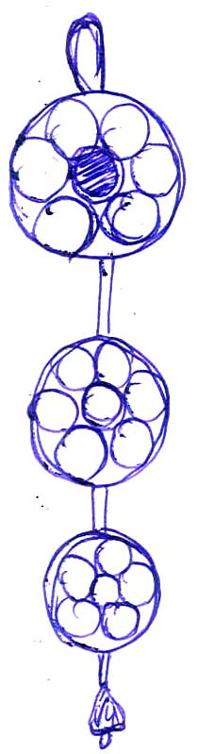
Material required:-
Cardboard or old marriage card,Colourful paper,
Pom-Pom, Ribbon,Feviocol,Mirror., Plastic bell or beads.
Follow these steps-
- Take one cardboard of round shape.
- Cover it with colourful paper.
- Paste a mirror in center of the cardboard.
- Paste Pom-Pom on covered cardboard.
- Make three pieces of decorative cardboard.
- Take one ribbon and paste these decorative pieces on
it with proper gap.

